CDN/H(15)032
Issue 1: 25/11/2015

UNCONTROLLED WHEN PRINTED

LeyboldTurbo : Architectural Design Document
Author: Peter Heesterman

Abstract
This document describes the high-level software design of the LeyboldTurbo EPICS application. It has been developed to monitor engineering data from the Oerlikon Leybold turbo-molecular pumps that are installed at JET. There is also some control capability.

R.O.: Peter Heesterman | Reviewer(s): Adam Stephen  David Kinna | Approver: John Waterhouse

Distribution
CODAS.
Table of Contents

Revision history 2
References 2
1. Purpose and Scope 3
2. Context of this Issue 3
3. Introduction 3
4. Glossary 3
5. Requirements 4
6. Controller Hardware and Packet TYPES 4
7. Real IOC and simulator 4
8. Process Logic - Threads and messages 5
9. Process Logic – Classes 5
9.1 CLeyboldBase 5
9.2 CLeyboldTurboPortDriver 6
9.2.1 LeyboldTurboRegistrar, LeyboldTurboPortDriverConfigure and LeyboldTurboAddIOPort 6
9.2.2 m_IOUsers 6
9.2.3 readInt32 and processRead 6
9.2.4 writeInt32 and processWrite. 8
9.2.5 readOctet 8
9.3 USSPacketStruct and USSPacket 8
9.3.1 SetDefault 8
9.3.2 CheckSum and GenerateChecksum. 9
9.4 CLeyboldPortSimDriver 9
9.4.1 LeyboldSimRegistrar, LeyboldSimPortDriverConfigure and LeyboldSimAddIOPort. 9
9.4.2 ListenerThread, octetConnectionCallback 9
9.4.3 Process 9
10. LeyboldTurboGUI 9
10.1 LeyboldTurboGUI.vi 10
10.2 GetPumpStatus.Vi 10
10.3 SetPVValue.vi 10
10.4 SetTabPages.vi 10
11. EDM Screen 10

Revision history

Issue | Author | Date | Description
1 | Peter Heesterman | 03/09/2015 | Written after the development phase was completed.

References

Ref. | Document | Date | Details and version
SMG | LeyboldTurbo : Software Maintenance Guide | 25/11/2015 | Issue 1
EPICS | EPICS Handbook |  | Issue 1
Asyn | asynPortDriver C++ Base Class for Asyn Port Drivers | 06/02/2009
Digital | RS 232 Interface for MAG.DRIVEdigital | 11/2008 | 17200148_002_A1
TD20 | RS 232 and RS 485 Interfaces for Turbo.Drive TD20 classic | 08/2006 | 17200048_002_00
Integra | Serial Interfaces for MAG integra | 08/2011 | 300336926_002_A1
Maglev | RS 232 and RS 485 for MAG.DRIVE iS | 04/2007 | 17200309_002_00

Purpose and Scope
This document describes the architecture of the LeyboldTurbo application. Together with the System Maintenance Guide, this document is for the benefit of developers who need to maintain the software.

Context of this Issue
Of the 4 pump models itemised, the software has been tested using the TD20 Classic pump controller at ISIS (MICE), the MAG Drive Digital controller at JET and the Maglev used by Diamond.
Use of the Mag Integra model has not tested as none is available, but the software would be expected to work using the 24-byte packet type¹.
¹See section 6 for a description of packet types.

Introduction
JET has 6 Leybold Mag Drive Digital turbo-molecular pumps in service.
Historically these have been monitored using Leybold-written Windows application(s) TPRun and TD_Panel.
These applications:
- Are not intended for customer use and are not supported by Leybold.
- Cannot run on Windows version(s) after XP.
- Do not provide a means of integrated data recording.
- Do not automatically start working after e.g. the PC has been rebooted.
These issues have driven a need to provide a suitable enterprise-integrated application.
Due to CCFE’s strong interest in EPICS as an enterprise architecture, a decision was made to base the application on EPICS.

Glossary
The intended audience is assumed to have prior familiarity with EPICS. Nonetheless a brief glossary of EPICS terminology is given here.

Term | Meaning
IOC | Input Output Controller
Asyn | An Interface between EPICS Drivers and Device Support
Channel Access | The network protocol used by EPICS applications
PV | Process Variable.  A named value object that is accessible by means of Channel Access

Requirements
The system is required to perform a number of functions. These are:
- Monitor engineering data values.
These will include:
- Whether the pump is running.
- Any fault status.
- Any warning status (there could be more than one).
- The numerical values:
  - Pump rotation speed.
  - Converter temperature.
  - Motor current
  - Pump temperature.
  - Circuit voltage.
- If there is a fault status, this should signal an alarm by setting the STAT field of the appropriate process variable.
- It shall be possible to turn the pump on or off. This capability should be restricted at JET to the authorised user group ‘vcops’ (operators of the vc subsystem computer).
- If the pump has an error status, it shall be possible to perform a system reset. This capability should be restricted to the same authorised as above.
- It will be a JET system requirement that data can be viewed by means of the vc subsystem interface. Local PC-based GUI interface(s) may also optionally be provided; such an interface could be by means of LabVIEW, or EPICS EDM, or CSS.
- It should be possible to view historic archived data by means of EPICS tools. These tools are outside the scope of this IOC project.

Controller Hardware and Packet TYPES
- The pumps operate using the USS communication protocol.
- There are two different packet types, depending on the controller model. Each of these has an 11-byte header and a 1-byte checksum footer:
  - Older models like the TD20 Classic have a 6-word PZD (Process Data) area, so that the packet size is 11 + 12 + 1, or 24 bytes.
  - The newer MAG Drive Digital controller that is used at JET has a 2-word PZD area and the packet size is 11 + 4 + 1, or 16 bytes.
The design requirement to support both packet types has been implemented in a templated manner.

Real IOC and simulator
The software is built (see [SMG]) as 2 IOCs:
- There is a real IOC, “LeyboldTurboApp”. This is composed of an EPICS device (i.e. library) “LeyboldTurboDev”, as well as the IOC shell. This construction allows developers to integrate the device library with an IOC shell that is already using other code – i.e. to support multiple devices within one IOC.
In normal use, LeyboldTurboApp will direct its I/O communication to the RS232 port that is connected to the controller. However, the I/O can also be directed to an IP port, which allows it to be directed at the simulator IOC.
- There is the simulator IOC “LeyboldTurboSim”. This acts as a socket server, receiving packets from LeyboldTurboApp and responding in a manner that closely resembles that of a real pump controller.
This approach allows the software to be developed and tested, in the absence of a real pump and controller. Such testing is only a partial substitute for the ‘real thing’, but it is very helpful.

Process Logic - Threads and messages
The CLeyboldTurboPortDriver IOC operates within threads that are implemented by the Asyn module base class. It does not itself implement any additional threads.
The CLeyboldSimPortDriver simulator IOC implements a thread that waits for, processes, and responds to USS packets that have been sent by the main IOC.

Process Logic – Classes
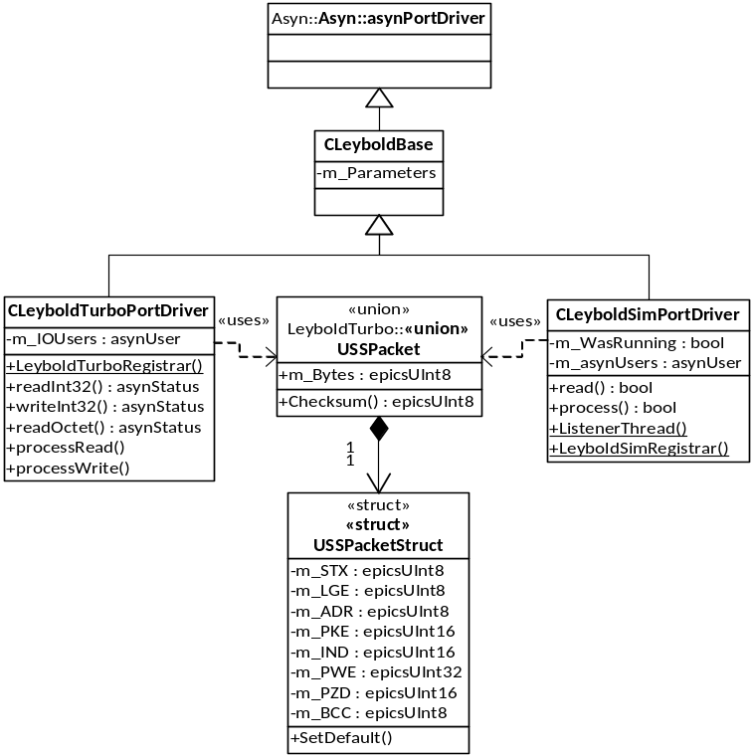
- See Leybold’s document(s) [Digital], [TD20], [Integra] and [Maglev] for a definition of the fields of the packet structure.

Figure 1 Class Structure Diagram

CLeyboldBase
This is a base class for the CLeyboldTurboPortDriver and CLeyboldSimPortDriver classes.
- It defines a CException class which is thrown for error handling.
- It provides wrapper methods around asynPortDriver [Asyn] parameter getters and setters. The methods use the parameter name as index, and throw an exception on error.
- The class holds a lookup of name to integer index in the m_Parameters map.

CLeyboldTurboPortDriver
This class implements the IOC application that communicates with the pump controller (or simulator).

LeyboldTurboRegistrar, LeyboldTurboPortDriverConfigure and LeyboldTurboAddIOPort
This method is invoked by the EPICS framework from the st.cmd script that is used to launch the IOC. The method registers two additional methods that will be invoked from the st.cmd script:
- LeyboldTurboPortDriverConfigure. This method is called once and passes 3 parameters from the script to the code:
  - The Asyn port driver name – typically ‘LEYBOLDTURBO’ - which is used to generate the PV names.
  - The number of connected pumps. Tested use cases are 1, 2 and 6, but in principle any number is valid.
  - The number of process data (PZD) array fields. As noted, this is either 2 (for the MAG drive digital rear port) or 6 (for other hardware configurations).
- LeyboldTurboAddIOPort. This method is called once per configured pump. The name of the Asyn internal port name should be passed, along with the port number index. Typically, this might be ‘PUMP:1’ It could also (but does not have to be) the same as the Asyn port driver name. This value maps to a physical serial port name, typically ‘COM1:’ on Windows, or ‘/dev/stty0’ on Linux.

m_IOUsers
Methods like readInt32 have an asynUser object passed in by the Asyn framework as parameter. But this object is associated with the EPICS database, and not with the I/O that needs to be invoked in order to communicate with the hardware. If the database-bound asynUser object is passed to I/O access methods, it causes an access violation.
Each connected device needs to have an asynUser object associated, and these are stored in this vector. The asynUser is a handle to data that is used by the input/output.

readInt32 and processRead
The readInt32 virtual method is overloaded from the Asyn method of the same name. It is invoked by the Asyn framework to read the ‘STATORFREQUENCY’ parameter value once every 5 seconds.
The USS packet data is not specific to any one data field, so all data values are updated in response to this polling request.
readInt32 first sends a passive status request packet, and then waits for the response.
The processRead method validates and processes the response value, and then updates database values.
For both packet types:
- Fault, warning and status information is contained in the first process data element m_PZD[0].
- The stator frequency information is contained in the second process data element m_PZD[1].

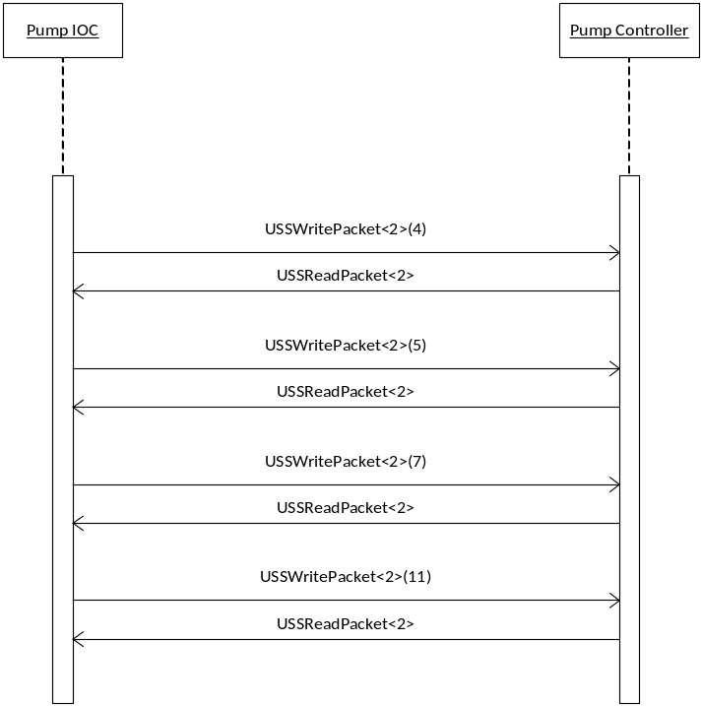

Figure 2 Communication with 16-byte (NoOfPXD=2) packet.

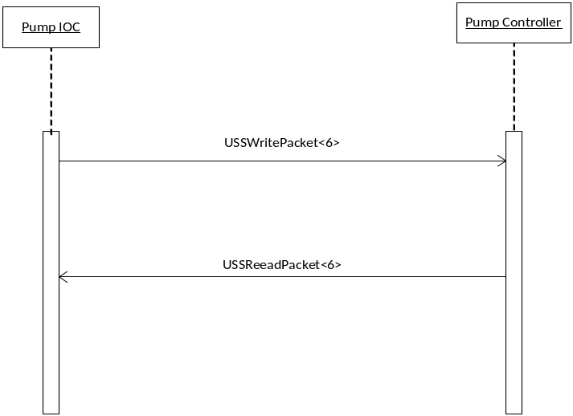

Figure 3 Communication with the 24-byte (NoOfPXD=6) packet structure.

processRead is overloaded for the 16-byte (NoOfPXD=2) and 24-byte (NoOfPXD=6) packet types in order to support both types of pump communication. This logic is illustrated by the sequence diagrams above.
For the 16-byte (NoOfPXD=2) packet type, readInt32 then needs to explicitly request the values:
- CIRCUITVOLTAGE
- MOTORCURRENT
- PUMPTEMPERATURE
- CONVERTERTEMPERATURE
All of the values are included in the 24-byte (NoOfPXD=6) passive packet. Both packet types contain the STATORFREQUENCY value.

writeInt32 and processWrite.
This virtual method is overloaded from the Asyn method of the same name, and sends a command to the controller. There are only two possible commands:
- Toggle the pump ON or OFF.
There are intermediate states ACCEL, DECEL and MOVING.
  - ACCEL is treated as an ON state (in that it is possible to issue an OFF command).
  - DECEL and MOVING are treated as OFF states (in that it is possible to issue an ON command).
- Reset the pump if it is currently in a fault state.
The work of this is done by processWrite. This also invokes processRead to update read-back values with the contents of the response. This behaviour is the same as polled values that will be generated by readInt32 a few seconds later.

readOctet
This virtual method is overloaded from the Asyn method of the same name and is used to read a string value from the controller. The only possible string value is the firmware version of the controller.
The firmware version value is not used by the software; it is intended for user verification display only.
This value is read once on software start-up and is assumed not to change while the software is running (although it would be possible to replace or upgrade a controller).

USSPacketStruct and USSPacket
These two are synonymous structures. The latter is a union that permits access to the data as a byte array, rather than as a structure.
Both are templated in order support the two different packet types. This is important because the PZD array precedes the checksum value and the structure must be contiguous in memory in order to be correctly transferred over the communication link.
A related issue is that the structure must be packed on byte boundaries in order to have the correct size and be transferred correctly. By default a compiler can optimise structures on 4 or 8-byte boundaries by means of padding – this optimisation must be prevented.
When Microsoft Visual Studio is used on the Windows platform, byte packing is achieved by means of #pragma pack directives. GCC documentation states that this usage is supported for compatibility, but it was found that the compiler in Scientific Linux ignored the Microsoft directive. Consequently the equivalent GCC directive has been added as well.
The USSPacketStruct is of course a reflection of the USS protocol as documented by [Digital], [TD20] and [Integra].

SetDefault
This method (invoked also by the constructor) sets the field values to default contents that will be used for writing to the controller.
- Bit 0 if m_PZD[0] is set if the pump should be running – though this is only treated as a command when bit 10 is also set.
- A parameter value request is made when:
  - The task field AK (bits 12-15) of m_PKE is set non-zero.
  - The parameter number (bits 0-10) of m_PKE is set to a non-zero parameter.
The value is then returned in m_PWE.

CheckSum and GenerateChecksum.
It is the behaviour of the USS protocol that each packet must be accompanied by a checksum in m_BCC.
If a packet is sent to the controller with a faulty checksum, it will be ignored – there is no error reply. If a packet is received by the software with a faulty checksum, it will be discarded and reported as an error.

CLeyboldPortSimDriver
This class provides a simulator that can be used for mocked development and testing of the main IOC. It’s an IP socket server that will accept connections, thereby substituting for serial port I/O. Asyn rather conveniently accepts this substitution with little change being required in either coding or configuration.

LeyboldSimRegistrar, LeyboldSimPortDriverConfigure and LeyboldSimAddIOPort.
This method registers the LeyboldSimPortDriverConfigure and LeyboldSimAddIOPort functions so they can be invoked from the st.cmd script.
- LeyboldSimPortDriverConfigure - this method is called once and passes 3 parameters from the script to the code:
  - The Asyn port driver name – typically ‘LEYBOLDTURBOSIM’ - which is used to generate the PV names.
  - The number of connected pumps. Tested use cases are 1, 2 and 6, but in principle any number is valid.
  - The number of process data (PZD) array fields. As noted, this is either 2 (for the MAG drive digital rear port) or 6 (for other hardware configurations).
- LeyboldSimAddIOPort. This method is called once per configured pump. The name of the Asyn internal port name should be passed, along with the port number index. Typically, this might be ‘PUMP:1’ It could also (but does not have to be) the same as the Asyn port driver name. This value maps to an IP port, e.g. localhost:5069.

ListenerThread, octetConnectionCallback
The callback method is scheduled with the Asyn framework on a socket connection event. It launches the ListenerThread to serve packet requests received from the main IOC.
The ListenerThread waits for and validates data packets by calling read(). When a packet is received, it calls process().
The thread is signalled to exit by setting m_Exiting.
The class destructor ensures that the thread has exited, prior to deleting resources.

Process
There are two overloads:
- One that processes only the 24-byte packet to set the contents of m_PXD[2] to m_PXD[5].
- One that processes either the 16-byte or the 24-byte packet, which includes setting m_PXD[0] and m_PXD[1]. Explicit value requests cause m_PWE to be set, as per the pump controller’s behaviour.

LeyboldTurboGUI
At the time of writing, integration of the pumps IOC into the JET control system had not yet been implemented. Consequently, there was a need to provide a GUI interface on the local PC for the benefit of end users.
This has been implemented in LabVIEW. The application supports a maximum of 6 pumps by means of the Tab Control. If there are fewer than 6 pumps, additional tabs are hidden (it is not possible to delete them).

LeyboldTurboGUI.vi
This is the application main VI and follows the State Machine design pattern. The application has three states, Init, Run and Terminate.
The Init state prepares the GUI, by calling SetTabPages.vi.
In the Run state, the application uses a LabVIEW event handler to respond to user button presses. There are only two possible controls (for each pump): The Running button and the Reset button. The application VI invokes SetPVValue.vi to apply either of the control values.
The Timeout event is used to poll the value of the PVs corresponding to the currently-selected tab. It does this by invoking GetPumpStatus.Vi.

GetPumpStatus.Vi
This VI reads out the current value of each the PVs that are associated with each pump controller. For convenience, the VI is sub-divided into GetMeasurments.vi, GetWarnings.vi and GetFault.vi. These respectively read out measurements, warnings and fault conditions. GetPumpStatus itself reads out the ‘Running’ and ‘Reset’ status fields.

SetPVValue.vi
This VI applies either of the ‘Running’ or the ‘Reset’ values to the pump controller. In each case, there is a confirmation dialog “Are you sure you want to…”.

SetTabPages.vi
This method hides additional tabs (if there are fewer than 6), and sets each tab caption to the pump name. This is in response to environment variables NUMPUMPS and ASYNPORT<n> (where n is the pump number).

EDM Screen
An EDM screen has been provided by Peter Leicester (peter.leicester@diamond.ac.uk). He should be contacted for further information about this.

ASYN version issues

Earliest Supported Version
The software uses features that were introduced with Asyn version 4-19. Consequently earlier versions cannot be supported.

Asyn 4-26, I/O Intr and asyn:READBACK
The software includes a number of PV fields that are defined as outputs, and yet need to be capable of having their value changed internally (which is an "I/O Intr" SCAN behaviour).
The capability for this combination of behaviours was introduced with Asyn 4-26 in response to this request.
This behaviour was defined by Mark Rivers with the database record flag INFO(“asyn:READBACK”).
Consequently, there are two differences depending on whether Asyn prior to 4-26 is being used:
- Database definition (.db) files have two versions, one for Asyn version(s) prior to 4-26, and one for 4-26 or later.
- Prior to Asyn 4-26, the required behaviour would only work with output being forced by setting the “PROC” field of the in/output PV.

ASYN 4-27, COM port >= 10 and setParamStatus
When using Asyn versions prior to 4-27, it is not possible to specify a com port number greater than 9 using the ‘usual’ windows format ‘COM<x>:’. This is not an Asyn issue, it is rather a Windows issue and is documented here. It is, however, possible to use the format ‘\\\\.\\COM<x>’.
Asyn 4-27 makes this translation automatically but does not remove the colon character so that a port needs to be specified as COM<x>. This format is also acceptable for earlier Asyn versions.
In order to provide alarm status signalling (for the benefit of any user interface that needs to signal alarm state to the user by e.g. blinking the display.), the Asyn function setParamStatus is invoked. This results in setting the STAT field of the PV.
There was an intended behaviour change with Asyn 4-27. The change requires a code sequence to set a value. This change does not break usage of earlier Asyn version(s), however.

